OEC Update - Background Checks Unit - January 30, 2019
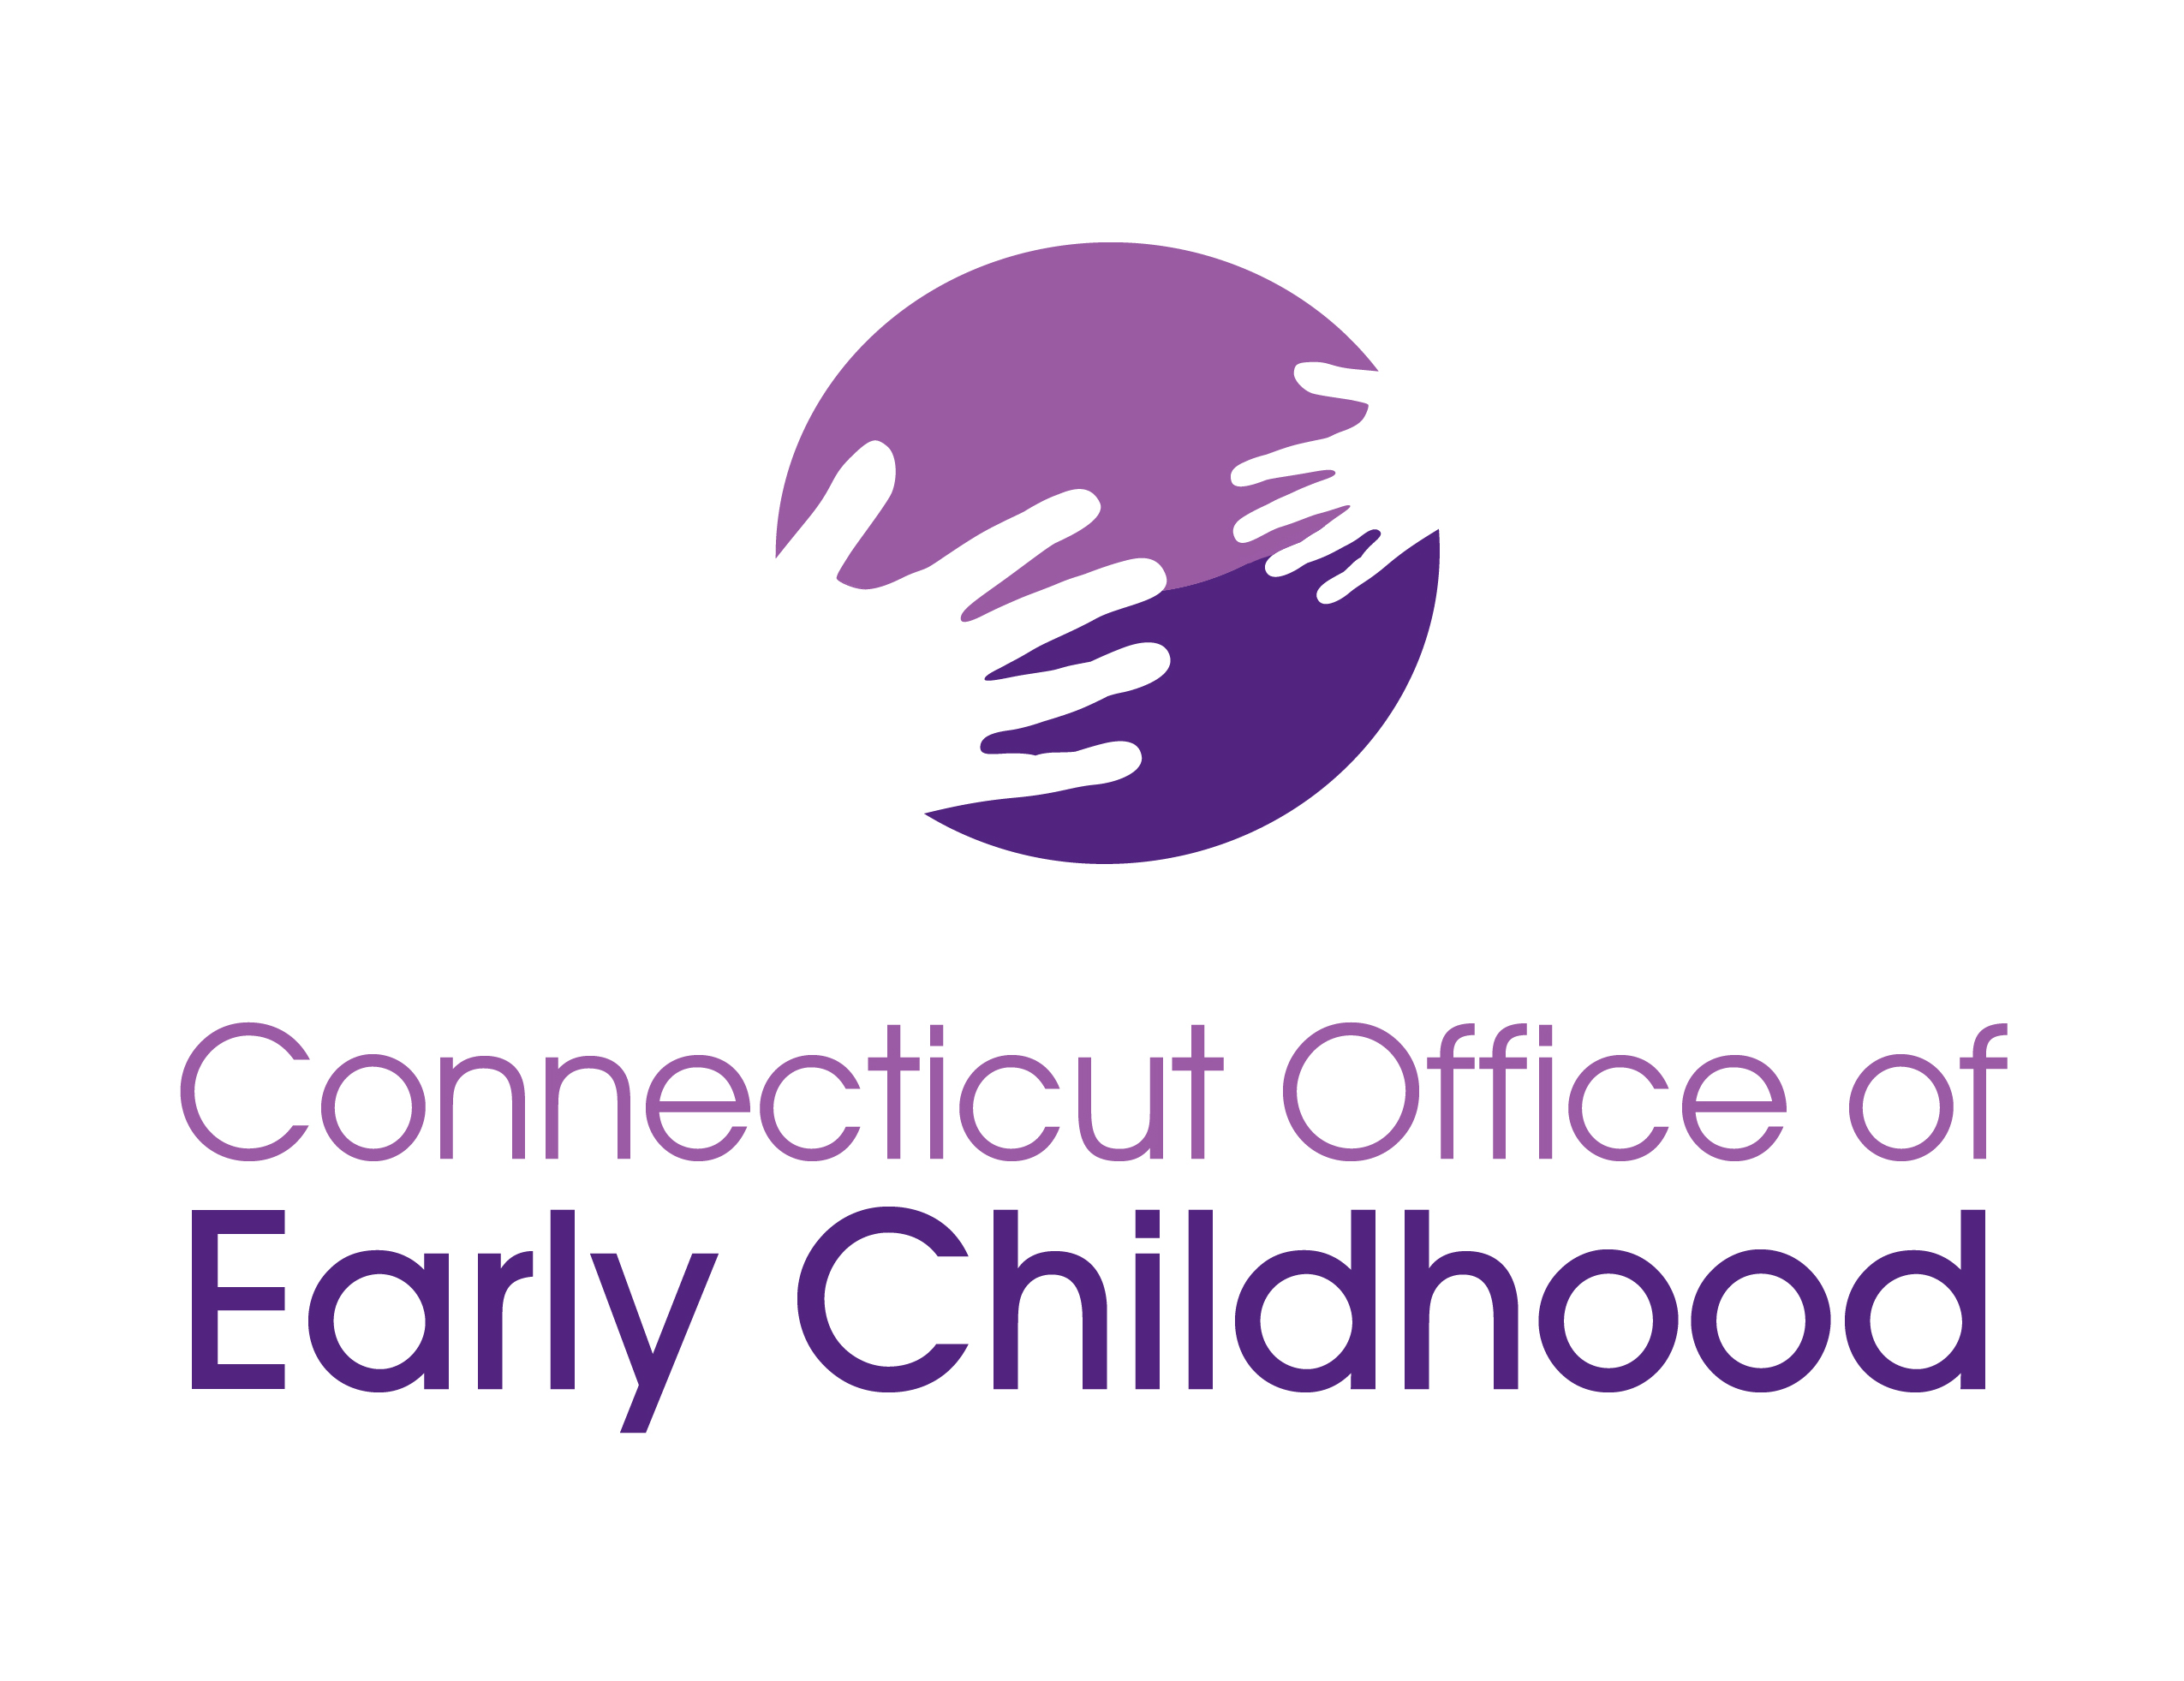

The CT Office of Early Childhood has a new Background Checks webpage!
You can find information in the same web location as before, right under the
OEC Licensing tab: https://beta.ctoec.org/background-checks/

We hope this new format will make finding answers to your questions easier than ever!
- Use the new Fingerprint Card Request form
- Print out other background check forms whenever you need them

Information on the webpage will be added and updated as needed, so visit often.

Don’t see something you need? Send your feedback or comments to OECfeedback@ct.gov

Thank you!

